**Week 2 Attempt Summary**

**Introduction**

In this week we were advised to create a load and process data function to a dataset with multiple features, with the following functional requirements

* Should be able to specify and start and end date for the whole dataset
* Deal with Nan values in the dataset
* Split train/test data according to a specified ratio (Date)
* Should be able to download the data to the local machine and store them to future use
* Scaling in the data structure

**Load_and_process_data Function**

Even If I managed to get the code working to get an output in the terminal, I failed to get the data visualized in the plot

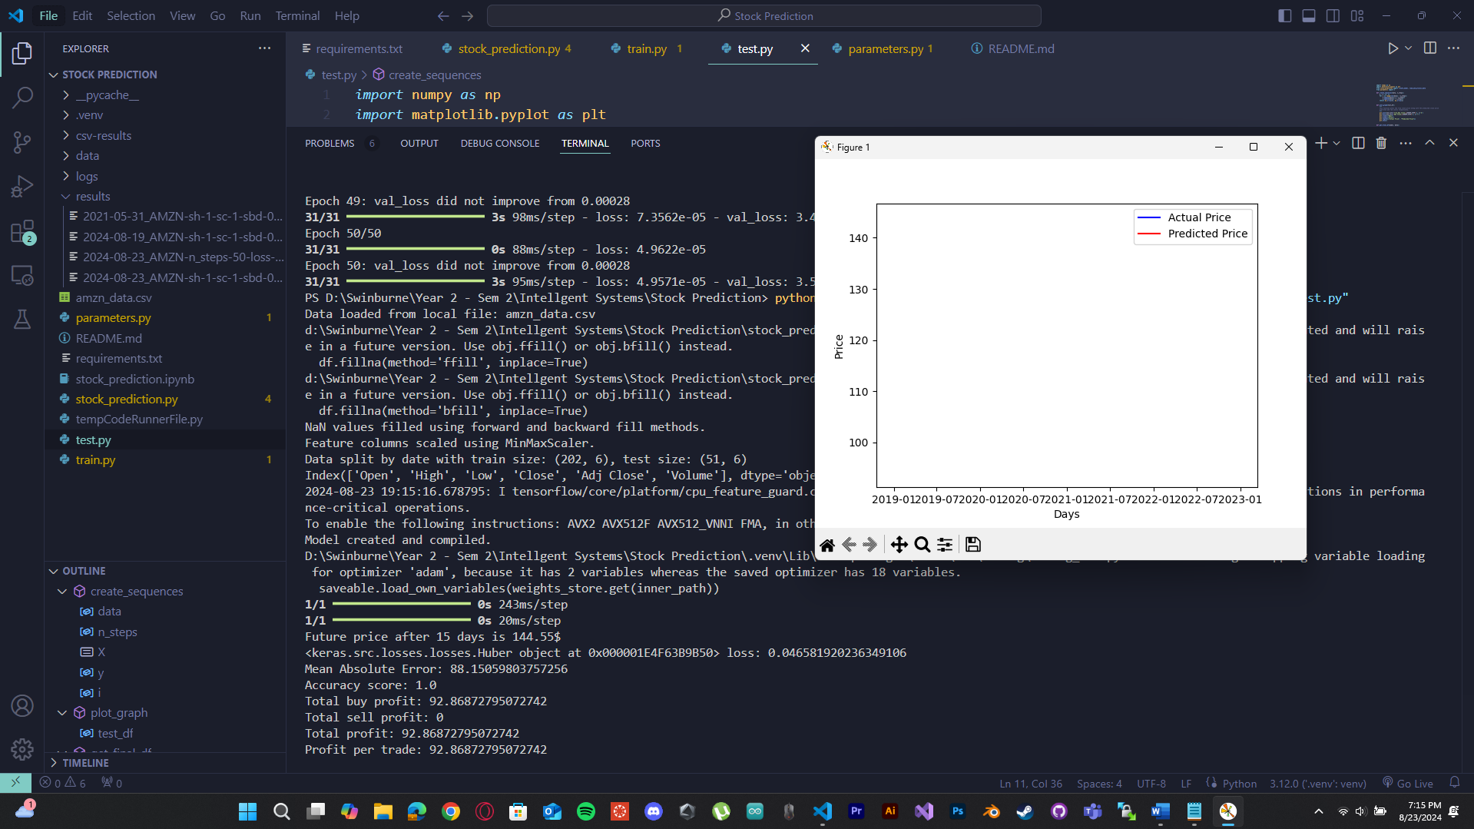

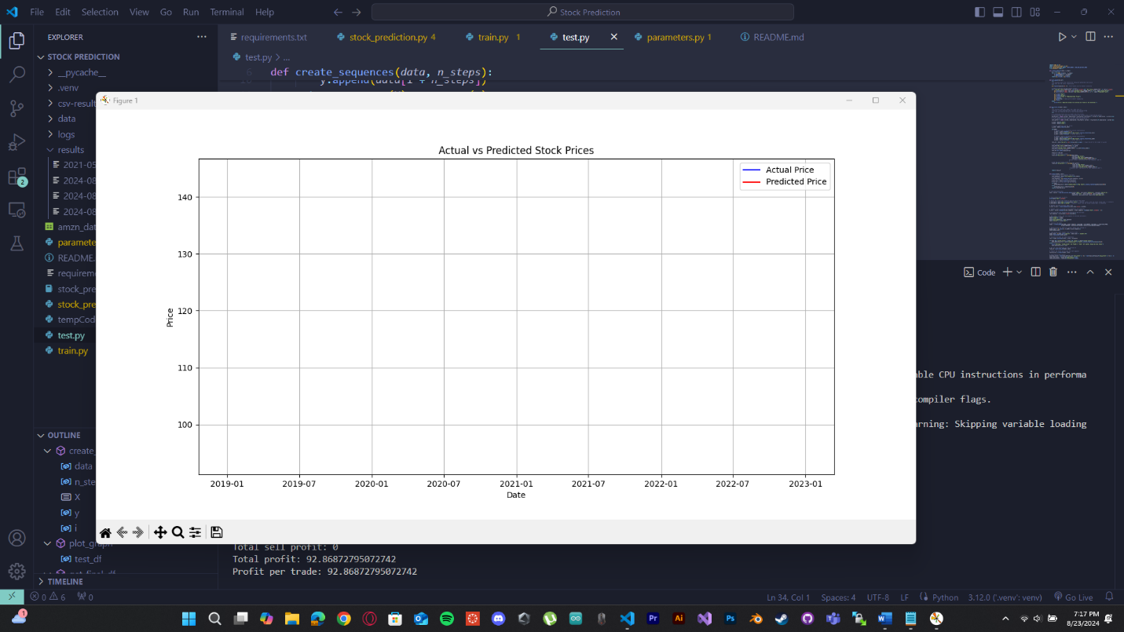

**How the load and process data function work**

This function is designed to load historical data, process it by handling Nan values, scaling and then splitting the data into training and testing datasets and then save the processed data locally for future usage.

**Parameters**

Ticker – The Ticker Symbol is used identify a specific stock market, in our case its amazon. So, AMZN

Start and End dates

Operations for Nan values – “drop” or “fill” – filling out Nan values from backwards or forward fill methods

Split ratio – the ratio of splitting the training and testing data, 0.8 refers to 80% training and 20% testing data

Boolean (Split by date) = Defaulted to True

Scale – preprocessed by minmaxscaler

**While researching data splitting, I stumbled against some data splitting techniques**

* **Simple Train-Test Split**: The most straightforward method, where the dataset is randomly divided into a training set and a test set, typically in an 80:20 or 70:30 ratio. This method is simple but can sometimes lead to variability in the performance of the model depending on how the data is split and this is the splitting method that I have used in this variation of the code base with the option to split data by date (80:20 ratio)
* **Stratified Split**: Particularly useful for classification tasks, stratified splitting ensures that the distribution of classes is consistent across both the training and test sets. This is crucial when dealing with imbalanced datasets to ensure that the model learns from all classes proportionally.
* **K-Fold Cross-Validation**: In k-fold cross-validation, the dataset is divided into k subsets (folds). The model is trained on k-1 of these folds and validated on the remaining fold. This process is repeated k times with each fold serving as the validation set once. The results are then averaged to provide a more reliable estimate of model performance.
* **Holdout Validation**: Similar to the train-test split, but with an additional validation set. A part of the data is held out for validation purposes, which helps in tuning the model before the final evaluation on the test set.